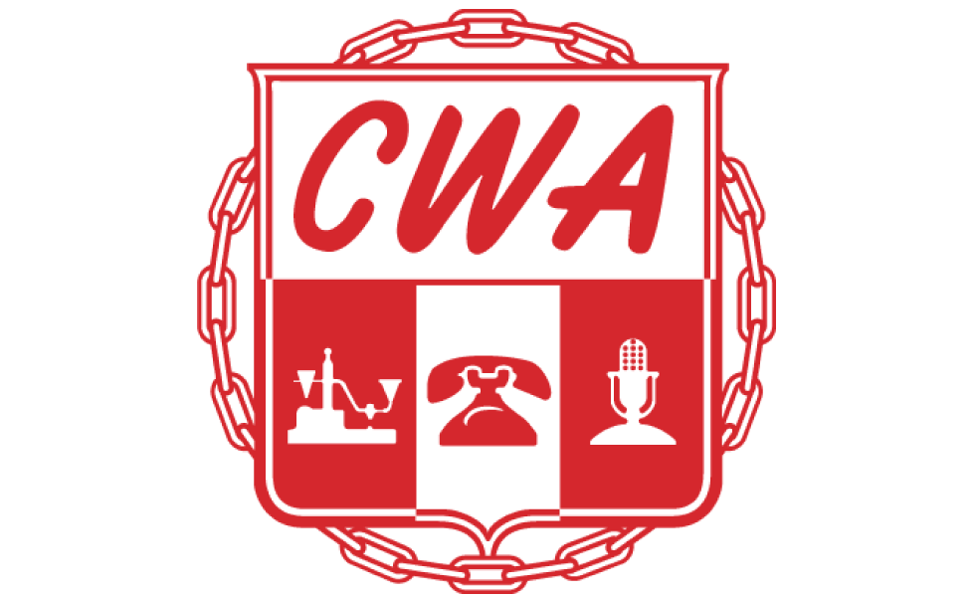Communications Workers of America Local 3106, AFL-CIO

RECORD OF INFORMAL GRIEVANCE SETTLEMENT

Grievant Name: {{ grievant_name }} Grievance # {{ grievance_number }}

Date of Informal Meeting with Management: {{ informal_meeting_date }}
Company Representative in Attendance: {{ company_rep_attending }}
Union Representative in Attendance: {{ union_rep_attending }}

Issue and Article of Contract Involved: Article#: {{ issue_article }}

{{ row.text }}

Settlement:

{{ row.text }}

Signer Role | Signature | Date
Company Representative | {{ Sig_es_:signer1:signature }} ____________________ | {{ Dte_es_:signer1:date }}
Steward | {{ Sig_es_:signer2:signature }} ____________________ | {{ Dte_es_:signer2:date }}
Grievant | {{ Sig_es_:signer3:signature }} ____________________ | {{ Dte_es_:signer3:date }}

